# BREAKING



Red Sox 10, Braves 7, 9th inning



**Same-Day Transcription**

Rev.com

**Learn more**

**Boston officer shot after felon is**

**pulled over**

**By Evan Allen, John R. Ellement and Meghan E. Irons**

Globe Staff, January 8, 2016, 12:15 p.m.

**114**

When the Boston Police drug unit officers saw Grant Headley cruising down Mount Bowdoin Terrace on Friday morning, they suspected the convicted felon was selling drugs, police said later. They pulled him over and boxed him in.



Replay

Learn More

**Dubai is leading the way in healthtech and providing a gateway fo…**

SPONSORED BY BUSINESS DUBAI

**See More**

But the 27-year-old, who was wanted for violating his probation, did not go quietly. Headley allegedly leapt from his car and opened fire, wounding a nine-year veteran in the leg and sparking a shootout, then taking off on foot before being tackled on Geneva Avenue, police said.

Thirteen preschoolers were just a few hundred yards away, out for a walk with their teachers.

“This individual had a dangerous path,” Boston Police Commissioner William B. Evans said at a press conference outside Boston Medical Center, where the injured officer was in the intensive care unit. “He didn’t want to go back to jail.”

Advertisement



**Same-Day Transcription**

Rev.com

Learn more

The officer, whom the Globe is not yet identifying because his mother has not been told of his injury, is expected to survive. He is a 37-year-old father of two who was less than a week away from receiving a commendation for bravery when he was shot.

**Get Today's Headlines in your inbox**

The day's top stories delivered every morning.

Enter Email

# BOSTON GLOBE VIDEO

[example@email.com](mailto:example@email.com)

**Sign Up**



2:23

Baker announces ‘VaxM SHARE

Headley, whose adult criminal record dates back more than a

Booking shot of Grant Headley. BOSTON POLICE DEPARTMENT

Related

Governor Charlie Baker announced residents who are fully vaccinated against COVID-19 will have the chance to win $1 million in a special Lottery sweepstakes. (Photo by Matt Stone/Boston Herald via AP)

decade and includes convictions for gun and drug charges, was released most recently from prison last April after serving five years on a host of gun charges, including being an armed career criminal in possession of a

**Photos: Officer shot in Dorchester**

**s ns’**

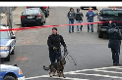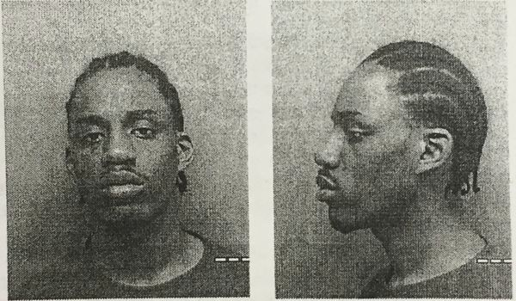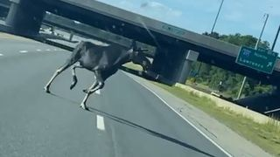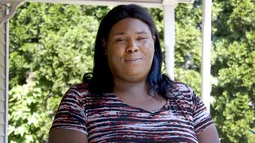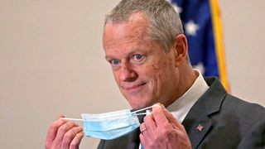

**Baker Moose What announce spotted Black ‘VaxMillio on liberation lottery Route 3 means program in to me:**

**Chelmsfo Athena**

**Vaughn**

**NOW PLAYING**

**Teachers led Dorchester**

**preschoolers through unusual day**

**rd**

**Live reports of police shot in Dorchester**

firearm without a firearm identification card.

On Friday, probation officers had a warrant for his arrest on charges related to violating his probation, though the nature of the violation was not immediately clear.

Evans said at the press conference that Headley was driving with a suspended license when drug unit officers stopped him.

Headley is in custody pending his arraignment, which is set for Monday in Dorchester Municipal Court.

Advertisement



**Carhartt**

**Shop Now**

Headley is being charged as an armed career criminal with a spate of charges, including assault and battery by means of a dangerous weapon and being armed while in the commission of a felony. He was not injured during his arrest, police said.

**MOST POPULAR ON BOSTONGLOBE.COM**

1. A treasure map for an American tyrant
2. Baker announces ‘VaxMillions’ lottery program, offering $1 million cash prizes to boost vaccination rates
3. Message in a bottle, tossed into the sea in Rhode Island, found in Azores
4. The case for prosecuting Donald Trump
5. America's blind spot: Thousands of drivers shouldn't be licensed
6. Patriots’ Dont’a Hightower is at minicamp to play football, and he can’t be any clearer
7. These Massachusetts organizations received donations from MacKenzie Scott
8. Death penalty should be reinstated for Tsarnaev in Boston Marathon bombings case, Biden administration tells Supreme Court
9. I got the Johnson & Johnson vaccine. The pause makes me believe in it more.
10. Lawmakers reach compromise on restoring pandemic era-policies including to-go cocktails, outdoor dining

Court documents list Headley as an alleged member of the Greenwood Street Posse gang, and an official said his nickname is “Young Gunna.” Relatives either could not be reached or declined to comment.

Evans called the shooting “unprovoked.” It occurred around 10:20 a.m. on Mount Bowdoin Terrace, which residents described as a mostly quiet street filled with longtime residents but one that has been troubled in recent months by drug problems and absent landlords.

Police officers who stopped his car had not even unholstered their weapons when Headley allegedly began firing, Evans said. Witnesses described hearing about five or six gunshots, close together. Gary Bell said the shots were so loud, he thought they were being fired in his backyard. When he looked out his window, he saw a man in blue jeans and a brown jacket racing down Mount Bowdoin Terrace, police officers behind him shouting “Police!” and “Stop!”

One of the officers, he said, stopped running and leaned against a car, blood pouring from his leg.



**Contact us today to learn more**

The PayPal Commerce Platform adapts to your business needs

PayPal for Business

**Sign up**

**VIEWS FROM OUR COLUMNISTS**

**YVONNE ABRAHAM**

Energy efficiency is a low- hanging fruit to combat climate change. So why can’t everyone get access to it?

**KEVIN CULLEN**

Bill Bratton on American policing and the challenge facing the Boston Police Department

**THOMAS FARRAGHER**

A salute across the ages to an old squad leader

**SHIRLEY LEUNG**

A working mother’s manifesto: Pandemic provides a once-in-a- generation chance to course correct how we work

**JENEÉ OSTERHELDT**

Juneteenth and the meaning of Black liberation in Boston

**ADRIAN WALKER**

‘The best Boston movie no one’s ever seen’: ‘Blue Hill Avenue’ at 20

A sudden, dramatic burst of chatter broke out on police radio at the time of the shooting, with officers reporting “shots fired,” and “officer shot,” according to audio archived by broadcastify.com.

About a minute in, the apparent voice of the wounded officer can be heard: “I am at 33 Mount Bowdoin Terrace. Shot.”

Advertisement



**Contact us today to learn more**

PayPal for Business

Sign up

“OK, sir, help is on the way,” replies the dispatcher. “Help is on the way.” A neighbor said it “happened so quickly.”

“I heard the shots and then police started chasing somebody,” said the man, who lives adjacent to the site of the shooting and spoke on condition of anonymity for fear of retaliation. “The police officer was on his back on the ground.”

Evans said officers at the scene shot back at Headley but did not hit him. The wounded officer tried to put a tourniquet around his leg, and another officer helped him. Evans said the quick application of the tourniquet might have saved the officer’s life.

Police chased Headley on foot across backyards on Rosseter Street, then onto Geneva Avenue, where he was wrestled to the ground and arrested without any more shots being fired.

Officers recovered a .40 millimeter semiautomatic Glock handgun at the scene, officials said.

“It’s a high-velocity handgun,” Evans said.

Mayor Martin J. Walsh, who visited the officer at the hospital with Evans, lauded the Boston police, whom he called “the best in the nation.”

“I commend the officers for their incredible restraint,” Walsh said.

The wounded officer is expected to recover from his injuries, officials said. Reporters who saw him entering the hospital said he was sitting up and alert when he arrived, and officials who spoke with him said he was conscious, and they thanked him for his service.

Advertisement

“In our mind, he’s a hero,” Evans said. “He’s out there doing God’s work.”

The officer was slated to be awarded a Commissioner’s Commendation on Thursday, along with three other officers, officials said, for bravery in handling a shooting in December. He was with three other drug unit members Dec. 15 on Brinsley Street when they saw a young man draw a firearm, chamber a round, and hand the gun to a companion. As the officers moved in, shots rang out, and the men attempted to flee. Police arrested three people at the scene and later at the hospital.

Authorities investigated the crime scene on Rosseter Street after a Boston police officer was shot in the leg Friday morning. CRAIG F. WALKER/GLOBE STAFF

Patrick Rose, president of the Boston Police Patrolmen’s Association, said in an interview that the officer had been a patrolman in Mattapan for seven years before moving to the drug unit in the same neighborhood. He has an exemplary reputation, Rose said.

“He’s very proactive, highly decorated. He’s a good guy. And that’s the best compliment a cop can give a cop,” Rose said.

The officer, who is from South Boston, is married and has two young children, Rose said. His mother recently underwent open heart surgery, Rose added. His wife and uncle were by his side at BMC Friday after the shooting.

Rose lashed out at Headley, saying he carried a gruesome nickname and a long violent history.

“His name, for crying out loud, is ‘Young Gunna,’ ” Rose said. “He was investigated for homicide. He is somebody who should not be out on the street.”

Advertisement

In the hospital press conference earlier in the day, Rose lamented the wide availability of guns on the streets and the dangers that officers face daily. Last March, Officer John Moynihan was shot in the face by a violent criminal whom police shot to death; Moynihan survived. Rose noted the Philadelphia police officer who was ambushed, shot, and wounded Thursday.

“There are far too many guns on the streets. The officers in the city of Boston do an excellent job collecting them, arresting people with those guns,” Rose said. “Bottom line is, though, we are the targets. And that’s wrong. We are the men and women protecting you in this city.”

Eric Moskowitz, Travis Andersen, and Martin Finucane of the Globe Staff contributed to this report. Evan Allen can be reached at [evan.allen@globe.com. John R. Ellement can be reached at](mailto:evan.allen@globe.com.JohnR.Ellementcanbereachedat) [ellement@globe.com. Meghan E. Irons can be reached at](mailto:ellement@globe.com.MeghanE.Ironscanbereachedat) [meghan.irons@globe.com.](mailto:meghan.irons@globe.com)

**Show 114 comments**

**MORE ON GLOBE.COM**

**SPONSORED BY: SUB- ZERO, WOLF, AND COVE**

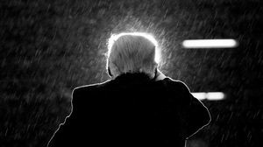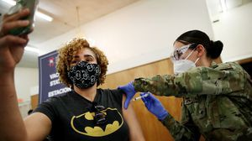

**Designing your ideal kitchen? Start with this guide.**

Selecting the right high-end appliances is the secret to a luxurious space that stands the test of time.

**The case for prosecuting Donald Trump**

Saving American democracy for the long run requires a clear condemnation of the Trump presidency. That means making clear that no one is above the law.

**5 things to know about the VaxMillions lottery sweepstakes in Mass.**

Here are five things you should know about the VaxMillions program, which will make some lucky winners living proof that trusting the science really does pay.

**America's blind spot: Thousands of drivers shouldn't be licensed** A Boston Globe investigation of how bureaucratic negligence has left lethal drivers on the road.

**RI NEWS**

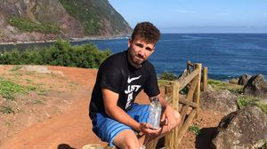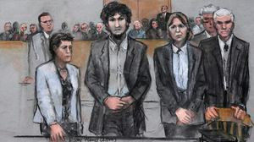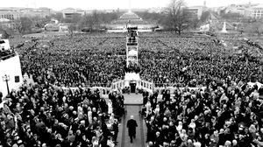

**Message in a bottle, tossed into the sea in Rhode Island, found in Azores**

The note was written in 2018 by a 13- year-old who was visiting family in Rhode Island.

**Death penalty should be reinstated for Tsarnaev in Boston Marathon bombings case, Biden administration tells Supreme Court**

The Biden administration is asking the Supreme Court to reinstate the death penalty against Dzhokhar Tsarnaev for the Boston Marathon terror bombings.

**Baker announces ‘VaxMillions’ lottery program, offering $1 million cash prizes to boost vaccination rates**

State officials on Tuesday said residents who’re fully vaccinated against COVID-19 will have the chance to win $1 million in a special Lottery sweepstakes.

**A treasure map for an American tyrant**

Donald Trump exposed weaknesses that a would-be dictator could exploit to end our democracy. It’s now up to lawmakers, voters, and public officials to prevent that from happening.

**Summer Reading 2021**

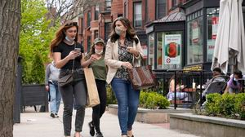

Here are 70 of the best books to pop into your travel bag.

**The downside of ditching masks: the return of colds, flu** Since the state’s mask mandate was lifted, face coverings have started to come off — and stay off. But according to infectious diseases doctors, the return of facial freedom might come with some downsides, like a resurgence in cases of the common cold and the flu.

**METRO SPORTS BUSINESS & TECH OPINION**

WELCOME, JOHN

**TODAY'S PAPER**

**Check out this week's virtual events**

RSVP now

**LAWMAKERS STRIKE DEAL TO RESTORE PANDEMIC-ERA POLICIES, INCLUDING EVICTION PROTECTIONS, TO-GO COCKTAILS**

**MOST READ IN THIS SECTION**

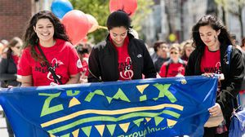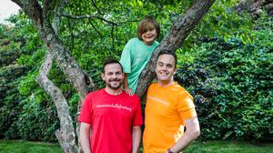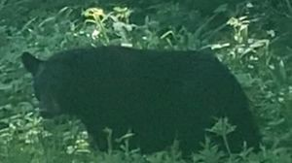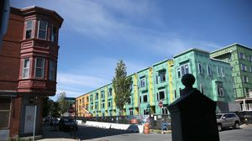

**Baker announces ‘VaxMillions’ lottery program, offering $1 million cash prizes to boost vaccination rates**

**RI NEWS**

**Message in a bottle, tossed into the sea in Rhode Island, found in Azores**

**These Massachusetts organizations received donations from MacKenzie Scott**

**America's blind spot: Thousands of drivers shouldn't be licensed**

**Death penalty should be reinstated for Tsarnaev in Boston Marathon bombings case, Biden administration tells Supreme Court**

**A Milton gay couple was harassed anonymously for years. Then a piece of handwriting unraveled the mystery**

**The downside of ditching masks: the return of colds, flu**

**‘Boo Boo’ the South Shore Bear captured on video roaming in Duxbury**

**With housing at center of Boston mayor’s race, labor and developers are organizing to push candidates**

**FOLLOW US**

**SUBSCRIBE NOW MY ACCOUNT CONTACT MORE**



Digital Access Home Delivery Gift Subscriptions

Log In

Manage My Account Customer Service

Help & FAQs Globe Newsroom Advertise

Newsletters / View The EPaper /

Order Back Issues / News In Education / Search The Archives / Privacy Policy / Terms Of Service / Terms Of Purchase / Work At Boston Globe Media /

Do Not Sell My Personal Information

©2021 Boston Globe Media Partners, LLC